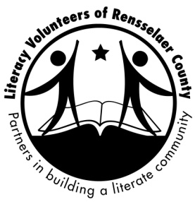
Celebrating 53 Years!

Famous Ladies’ Tea
Raffle Items
Sunday March 28, 2021
VIRTUAL EVENT

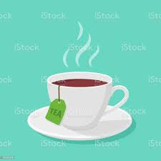
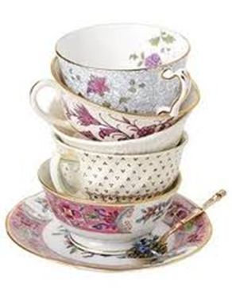
***RAFFLE ***

Tickets sold in advance of the
Famous Ladies’ Tea, March 28th

Ticket prices:
1 for $5 3 for $10
5 for $15 10 for $20
Best Deal 15 for $25

Please mail or drop off completed raffle tickets and money to office by 3/25.
Be sure to indicate on each ticket the Raffle item number.

ENJOY YOURSELF AND THANK YOU FOR SUPPORTING THE WORK OF LITERACY VOLUNTEERS OF RENSSELAER COUNTY
Raffle Items

R–1 Barbecue Basket: A sure sign of spring comes with this basket. Contains a Pampered Chef Slider Basket, barbecue tongs and spatula, a serving platter, 2 bottles of barbecue sauce, oven mitt and a $25 Gift Card to the Primal Butcher, located in Stuyvesant Plaza. Donated by Karen Druckman. Value: $100.
R-2 Women’s Real Rabbit Fur Fingerless Gloves: So fashionable. The fur is brown in color and so very soft. Donated by Lola Saratoga. Value: $90.
R- 3 Worthington Flowers Gift Certificate - Just in time for your spring or Easter flowers. Donated by Worthington’s, Wynantskill, NY. Value: $20.
R-4 Crossroads Grill Gift Card – WE’RE IN THE NEIGHBORHOOD. Located at 43 Mall Way, West Sand Lake. Donated by Crossroads Grill. Value: $25.
R-5 Comfort Gift Basket – Perfect to unwind and help you relax during this pandemic time. Includes a fleece blanket, sleep mask, lavender products, loofah, local jar of honey, a bar of raspberry dark chocolate and more. Donated by Myrna Bernstein. Value: $45.
R-6 Bigelow Tea Gift Basket: For the tea drinkers amongst us. This lovely basket includes a large assortment of teas & 2 large tea mugs. Donated by Bigelow Tea Co. Value: $50

Raffle Items Continued

R-7 Eat Sweets, Drink Tea, and Write Notes to Your Friends Basket – Basket contains local Fair Fern Honey (Averill Park), a handcrafted mug, various teas, dishtowels, note cards, Chocolate truffles from Deanna’s and more. Donated by Val Kavanaugh. Value $50.
R-8 A CAT LOVER’S BASKET: A basket ful of goodies for you and your favorite feline(s). For you, a cat shaped snack tray, two cute handmade wooden wall plaques, two books: “The Little Cat Facts Book” and ”If Cats Could Talk”, a little cat and mouse pin, and a package of lovely, handmade note cards. And for your fabulous feline(s), some gourmet food, treats and few toys. And when you empty the basket, you’ll find a pillow on the bottom, making it a perfect bed for your best friend. Donated by Stephanie, Socks, and Maya Weiss. Value: $60
R-9 ART PHOTOGRAPH - “Autumn Birches”, taken on Taborton Mountain: This beautiful 11 x 14 full color landscape is matted and ready for 16 x 20 frame. It is made with Epson premium acid-free photographic paper and Epson archival pigment based inks. Donated by Tom Chestnut of Taberton Mountain Photography. Value: $95.

Raffle Items Continued
R-10 ART PHOTOGRAPH – “Black Mountain Pond”, taken in the Adirondack Forest Preserve. This beautiful 11 x 14 full color landscape is matted and ready for 16 x 20 frame. It is made with Epson premium acid-free photographic paper and Epson archival pigment based inks. Donated by Tom Chestnut of Taberton Mountain Photography. Value: $95
R-11 Basket of Wine: Enjoy this fun sampling of LVORC’s Board of Directors & Friends’ Favorite Wines. Donated by Literacy Volunteers Board of Directors and Donna Denley. Value: $75.
R-12 Crofton Matching Set of 2 Tea Cups & Saucers: Perfect for enjoying a great cup of coffee or tea anytime of day. Donated by Mary Krenceski. Value: $20.
R-13 Adorn Salon Gift Bag: This package includes a sampling of Adorn hair products & KMS products. Donated by Adorn Salon located in Cropseyville, NY. Value: $72.
R–14 Harney & Sons WOODEN HEIRLOOM TEA CHEST: this beautiful bamboo wooden tea chest with black accents makes an elegant and delectable addition to any tea-drinker's arsenal. We've filled each chest with eight of our favorite teas, each variety carefully selected to appease every thirst. A total of 32 individually wrapped sachets per chest—just right for brewing up a pot to enjoy with friends, or savoring yourself over time. Donated by Harney & Sons Tea Co., Millerton, NY. Value: $79.
Raffle Items Continued
R-15 A Fine Quality Chinese Tea Set: Gold & White porcelain Chinese Tea ceremony Tea Set. Made in Jingdezhen, China, the “Porcelain Capital” for producing Chinese ceramics. Contains 10 cups with a total of 16 pieces. Donated by Marie Heller. Value: Priceless
R-16 Dessert Platter: A great way to serve your delicious desserts. The dessert stand is a toile design plate. Donated by Merrriman and Pfister’s Marketplace, Delmar. Value: $23.

R-17 Premier Designs Earrings: Wear and enjoy these lovely silver braided hoop earrings. Perfect for many occasions. Donated by a friend of LVORC. Value: $25.

R-18 Breakfast for Two: Start your day off with a great breakfast at the Four Corners Luncheonette, A Verdant Oasis in the Gustatory Badlands., Donated by Four Corners Luncheonette, 2 Grove St. Delmar, NY Value: $20.
R – 19 A Mary Kay Pampering Set: Include 2-in-1 Wash & Shave with hydrating lotion plus various Mary Kay product samples. Donated by Bev Freemantle, Mary Kay Independent Beauty Consultant. Value $50.

A special thank you to all of the businesses and individuals who so generously donated items to the 2021 Famous Ladies’ Tea Raffle.

THANK YOU FOR YOUR SUPPORT OF THE 2021 FAMOUS LADIES’ TEA

Please note that tickets this year are being sold in advance of the
Famous Ladies’ Tea, March 28th
Winners will be drawn at the conclusion of the Tea
Ticket prices:
1 for $5 3 for $10
5 for $15 10 for $20
Best Deal 15 for $25

